Test Summary Report

# Contents

1. *Report Description* 2
2. *Application Overview* 2
3. *Testing Scope* 2
4. *Metrics* 3
5. *Test Environment & Tools* 5

## Report Description

This report presents the results of the **Functional Testing** conducted on the Jumia Nigeria website (<https://www.jumia.com.ng>). As Jumia expands its e-commerce operations into the Nigerian market, this testing effort aims to ensure that critical user-facing features function as intended before production deployment. The report outlines the test objectives, scope, execution summary, defect breakdown, and overall system readiness assessment.

## Application Overview

Jumia Nigeria is a regional extension of Jumia’s leading e-commerce platform, designed to serve the Nigerian market by providing a robust online marketplace for buyers and sellers. It aims to expand Jumia’s reach in West Africa and enhance access to a wide variety of products ranging from electronics to fashion, groceries, and household items.

The website offers a fully functional, user-friendly interface that allows customers to browse, search, and purchase products online. The platform also enables vendors to register and manage their stores, upload products, track orders, and handle customer inquiries. It integrates secure payment gateways to support various local and international payment methods, including bank transfers, cards, and digital wallets.

## Testing Objective

A functional test was carried out on this application/sprint to verify the app functionality. The primary objective of this testing effort is to validate the functional correctness and compatibility of the **Jumia Nigeria website** (<https://www.jumia.com.ng>) before its official launch. This involves ensuring that all core user functionalities—**user sign-up, cart management, and checkout process**—operate seamlessly and per the defined business and technical requirements.

***4. Testing Scope***

This testing effort is focused on verifying the core user functionalities of the Jumia Nigeria website (<https://www.jumia.com.ng>) to ensure a reliable and seamless customer experience upon launch. The scope includes functional validation of key user journeys essential to the e-commerce workflow. This testing phase includes verification of key functionalities such as **user sign-up, cart management, and the checkout process**.

### In Scope

Functional Testing for the following modules is in the Scope of Testing

* + - * Sign Up
      * Managing Cart
      * Checkout

### Out of Scope

Performance Testing and Load Testing were not done for this application.

### Items not tested

List the other features in the application that were not tested

* Login
* Search
* Registry
* Language
* Returns and Orders

## Metrics

### No. of test cases planned vs executed

| **Test cases**  **planned** | **Test cases**  **executed** | **TCs**  **Pass** | **TCs**  **Failed** | **TCs Not Executed** |
| --- | --- | --- | --- | --- |
| 38 | 29 | 25 | 4 | 9 |

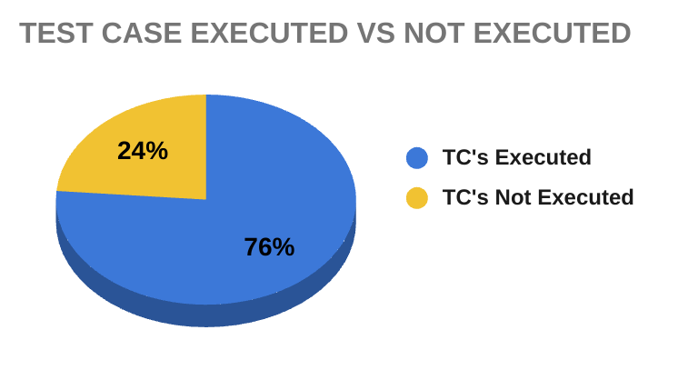

1. **No. of test cases passed/failed**

| **Test cases**  **planned** | **Test cases**  **executed** | **TCs**  **Pass** | **TCs**  **Failed** | **TCs Not Executed** |
| --- | --- | --- | --- | --- |
| 38 | 29 | 25 | 4 | 9 |

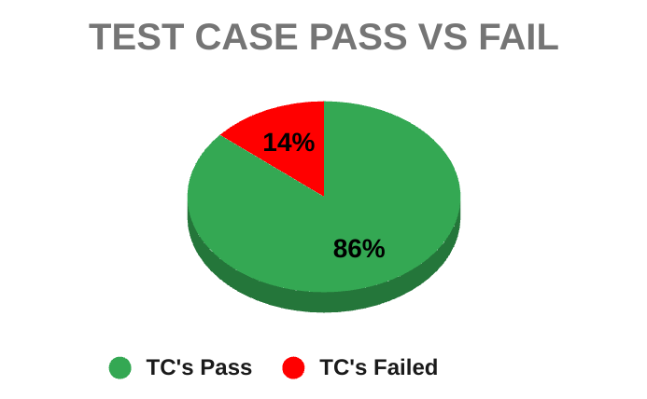

### Defect Summary

The table below summarizes the results of test case execution categorized by defect severity:

| **Severity** | **Pass** | **Fail** | **Not Executed** | **Total** |
| --- | --- | --- | --- | --- |
| **Critical** | 15 | 4 | 2 | 21 |
| **High** | 5 | 0 | 3 | 8 |
| **Medium** | 4 | 0 | 3 | 7 |
| **Low** | 1 | 0 | 1 | 2 |
| **Total** | 25 | 4 | 9 | 38 |

1. **Status distribution – feature-wise**

|  | **Signup** | **Managing Cart** | **Checkout** | **Total** |
| --- | --- | --- | --- | --- |
| **Passed** | 15 | 10 | 0 | **25** |
| **Failed** | 4 | 0 | 0 | **4** |
| **Not Executed** | 0 | 0 | 9 | **9** |
| **Total-->** | **19** | **10** | **9** | **38** |

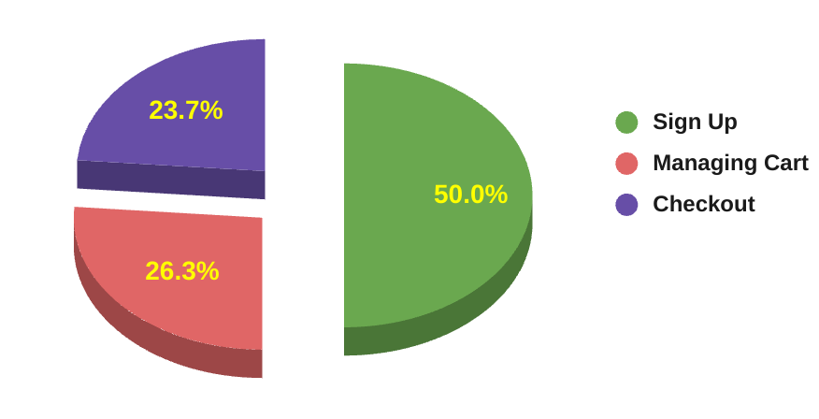

## Test Environment & Tools

This section outlines the hardware, software, and tools used during the functional testing of the **Jumia Nigeria website** (<https://www.jumia.com.ng>).

| **Application URL** | https://www.jumia.com.ng |
| --- | --- |
| **Operating System** | Windows 10  iOS 16.7.11 |
| **Browsers** | Google Chrome Version 135  Firefox  Internet Explorer |
| **Network** | Standard broadband internet connection |

## 